Religious Education: | Year 3 | Autumn 1 |  | Enquiry Question: Does joining the Khalsa make a person a better Sikh? |  |  |  |  | Religion: Sikhism
In this enquiry, you will look at one of the key stories in Sikh history. You will also reflect on the messages and begin to understand why some Sikhs would want to join the Khalsa.
What we will learn: |  |  |  |  |  | Link to other aspects of belief |  | Personal connection
- The story of Guru Gobind Singh and the Panj Pyare  - The Khalsa baptism ceremony which is called the Amrit ceremony.  - During the ceremony a drink called Amrit is drunk. Amrit is sugar and water that is stirred with a dagger. It must be drunk in the presence of 5 Khalsa Sikhs as well as the Guru Granth Sahib.  - The novice is instructed in the following;  - You shall never remove any hair from any part of thy body  - You shall not use tobacco, alcohol or any other intoxicants  - You shall not eat the meat of an animal slaughtered the Muslim way  - You shall not commit adultery.  - The novice is required to wear the physical symbols of a Khalsa at all times (known as the 5K’s) as well as follow the Khalsa Code of Conduct. |  |  |  |  |  | - Importance of the 10 Gurus  - Celebration of Baisakhi festival  - Worship in the Gurdwara  - Community care via the Gurdwara |  | - What would I be prepared to stand up for? What issues matter to me?  - Do I belong to a group or team?  - How do I show commitment?  - How could I show commitment to others?  - What 5 rules might I choose to follow?
Key Vocabulary |  |  |  |  | The Five Ks |  | Impact on believer/daily life
Sikh – ‘Disciple’ or ‘learner’ |  |  |  |  | 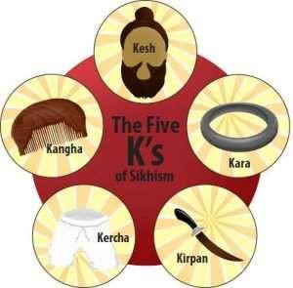 |  | - Moral code – Living life in a positive, helpful way  - 5 K’s – physical sign of commitment – being visible as a Sikh is a sign of commitment  - Personal choice as to when to join the Khalsa  - Service to others – Sewa – feeding people in the Gurdwara (langar)
Guru – ‘Teacher’ or ‘Leader’
Amrit Ceremony – joining the Khalsa |  |  | 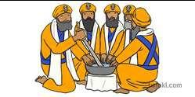
Khalsa – means ‘pure’ |  |  | 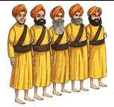
Home learning ideas/questions:
What is commitment? Can you explain if you think it is possible to show the same level of commitment to everything we do? Is there anything that you or your family belong to or regularly do which requires you to show commitment?

