Religious Education: | Year 2 | Autumn 1 |  | Enquiry Question: Is it possible to be kind to everyone all of the time? |  |  |  |  |  | Religion: Christianity
In this enquiry you will investigate how Christians might follow Jesus’ example of being kind to people.
What we will learn: |  |  |  |  |  | Link to other aspects of belief |  |  | Personal connection
- Summing up the Ten Commandments:  - “‘Love the Lord your God with all your heart and with all your soul and with all your mind and with all your strength.’  - ‘Love your neighbour as yourself.’ There is no commandment greater than these.” Mark 12:30-31  - That Jesus told parables to give examples of how to be kind.  - How Jesus told the story of the Kind Man (The Good Samaritan) to teach how we should be kind to everyone, including our enemies. |  |  |  |  |  | - Trinity: Jesus is the son of God so has the power to heal and forgive sins.  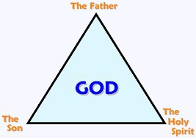 |  |  | - Are there some people that I find it easier to be kind to than others?  - How can I increase how kind I am to people I either don’t know very well or don’t like very much?  - What impact might this have on my life and my community?
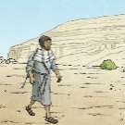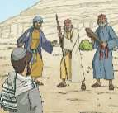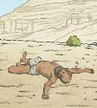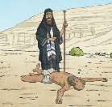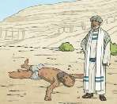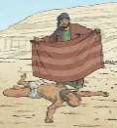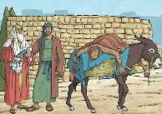
Key Vocabulary |  |  |  |  |  |  |  | Impact on believer/daily life
Samaritan: a person from Samaria, a country near where Jesus was teaching. |  |  | 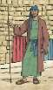 |  | Parables: stories that Jesus told to illustrate points he was trying to make in a way (or setting) that his listeners would understand. |  | 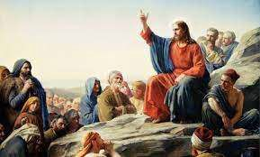 | Because of the examples Jesus gave, Christians believe everyone is their neighbour so they must care about people they may not know or like.  The Samaritan had no obligation to help the hurt Jew, especially considering the disdain which the Jewish race had for Samaritans, yet he does, so Christians try to emulate this.  Christians today feel that if they have faith and pray, then a healing miracle may occur.
Levite: a legal expert who would have known that it states in the law that he should help an injured man. |  |  | 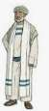 |  | Mary: the mother of Jesus. Mary was  visited by the Angel Gabriel and told that  she would have a baby, God’s son - Jesus
Pharisee: a strictly orthodox Jew who adhered closely to the rules and scriptures. |  |  |  |  | Joseph: a carpenter who married Mary, the mother of Jesus. He was to raise Jesus with Mary. |  | 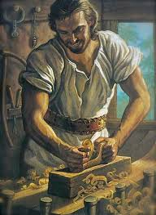
Home learning ideas/questions:
How do we feel about extending our circle of kindness to include people that we may not normally choose to interact with? Can we try to be even kinder to everybody in our household? What impact do we think this may have?

